Web API :

The ASP.NET Web API is an extensible framework for building HTTP based services that can be accessed in different applications on different platforms such as web, windows, mobile etc. It works more or less the same way as ASP.NET MVC web application except that it sends data as a response instead of html view. It is like a webservice or WCF service but the exception is that it only supports HTTP protocol.

Types for creating web api project :-

1. Web API with MVC Project
2. Stand-alone Web API Project

Web API with MVC Project:

For this, open Visual Studio and click on **File** menu and click on **New Project.** This will open New Project popup as below.

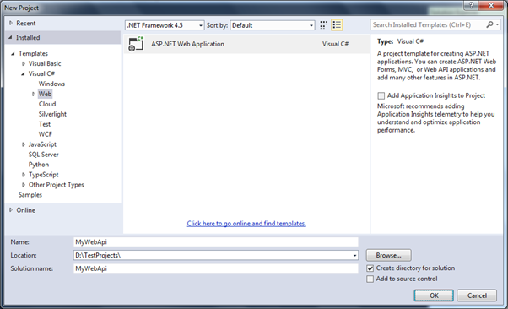

In the New Project popup, expand **Visual C#** and select **Web** node in the left pane. Select **ASP.NET Web Application** template in the middle pane and enter the name of a project and click **OK**. (ASP.NET Web Application (.NET Framework) template in Visual Studio 2017.)

This will open New ASP.NET Project popup as shown below.

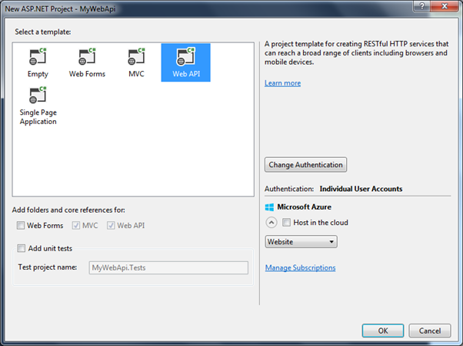

API Template

Select Web API in the above popup. Notice that this has selected and disabled MVC and Web API checkboxes. It means that it will add necessary folders and references for both MVC and Web API.

Click Ok to create a new Web API + MVC project as shown below.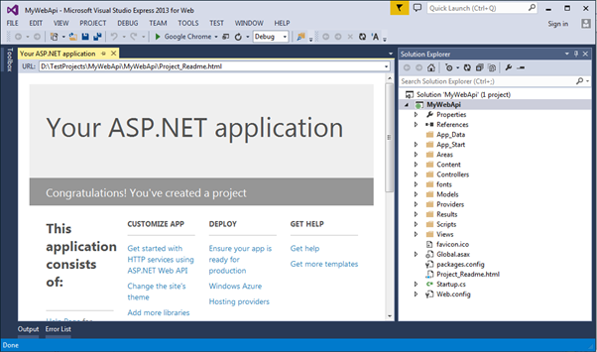

This project is same as default MVC project with two specific files for Web API, WebApiConfig.cs in **App_Start** folder and ValuesController.cs in **Controllers** folder as shown below.

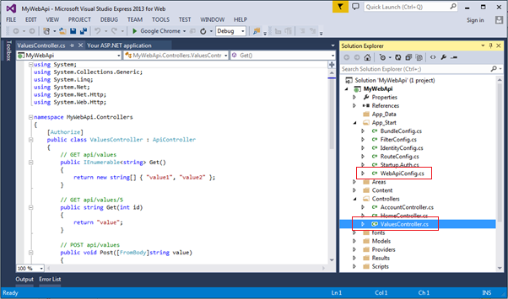

The WebApiConfig.cs is configuration file for Web API. You can configure routes and other things for web API, same like RouteConfig.cs is used to configure MVC routes. It also creates Web API controller ValuesController.cs by default.

# Stand-alone Web API Project :-

For this, open Visual Studio 2013 for Web -> go to **File** menu and select **New Project..**This will open**New Project** popup as below.

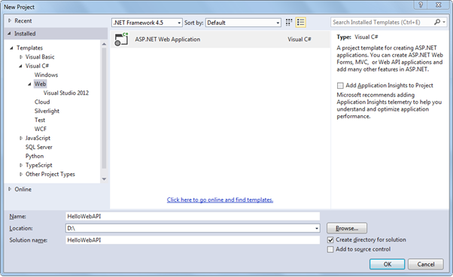

Select **Web** template in the left pane and **ASP.NET Web Application** in the middle pane. Enter a name of the project, location and Solution name as shown above. Clicking on **OK** will open a popup as shown below.

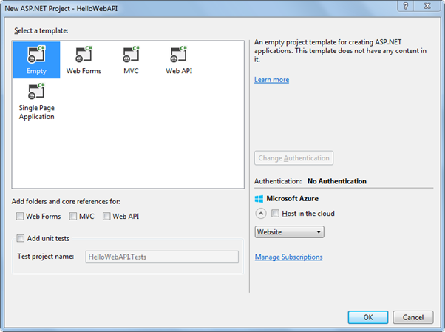

In the above popup, select **Empty** as a template and click ok. This will create an empty "HelloWebAPI" project.

Now, we need to add latest Web API references using **NuGet Package Manager**. Right Click on the project and click **Manage NuGet Packages..** as shown below.

Example: Web API Configuration :-

using System;

using System.Collections.Generic;

using System.Linq;

using System.Web;

using System.Web.Http;

namespace HelloWebAPI.Configuration

{

public static class HelloWebAPIConfig

{

public static void Register(HttpConfiguration config)

{

// Web API routes

config.MapHttpAttributeRoutes();

config.Routes.MapHttpRoute(

name: "DefaultApi",

routeTemplate: "api/{controller}/{id}",

defaults: new { id = RouteParameter.Optional }

);

}

}

}

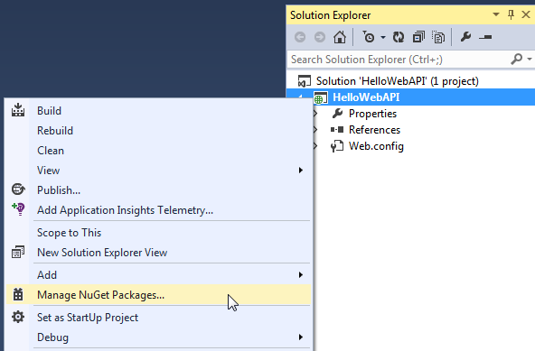

This will open Manage NuGet Packages popup. Select **Online** in the left pane and search for webapi (make sure that internet connection is on). This will display all the Web API related packages. Select **Microsoft ASP.NET Web API2.2** package and click on **Install** as shown below.

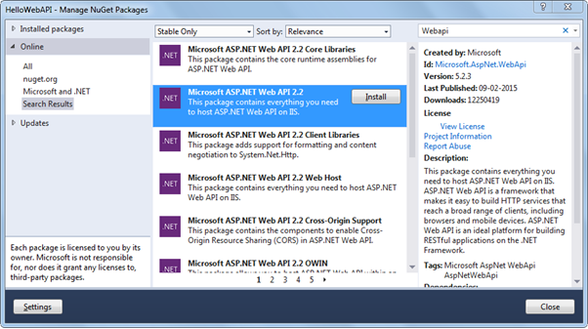Install Web API Package

Accept the license agreement and continue.

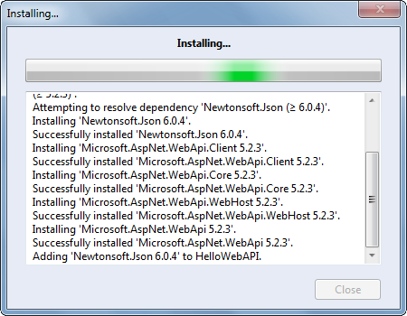Install Web API Package

The following Web API packages are displayed upon successful installation.

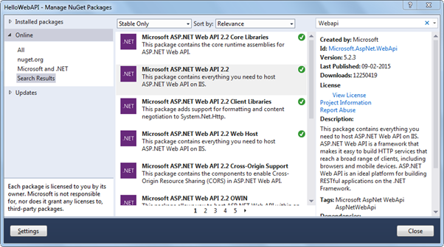Web API Packages

Now, create Controllers and Configuration folder in the HelloWebAPI project as shown below. We will add Web API controller in the Controllers folder and configuration class in the Configuration folder.

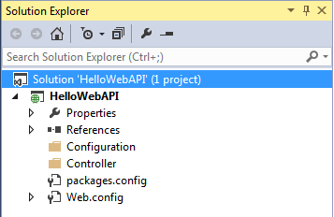Web API Project

Now, add a new class in the configuration folder and name it "HelloWebAPIConfig" with following content. (You may give any appropriate name)